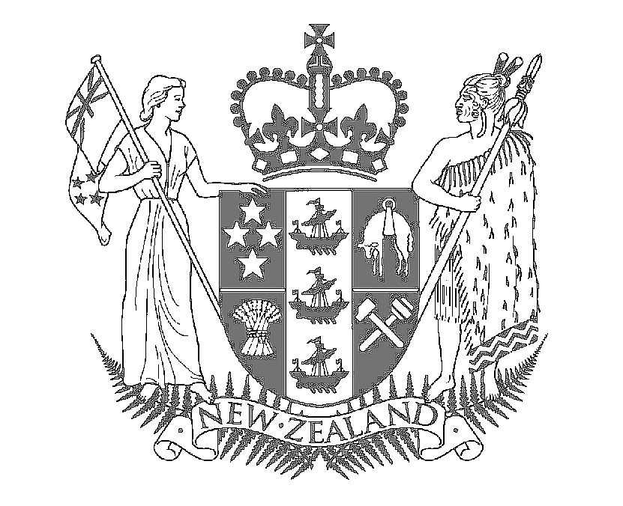

Speech Notes

HON MAHARA OKEROA
Associate Minister of Conversation

Signing of the Te Waihora Joint Management Plan

To be held at Te Waipounamu House
Saturday 10th December 2005

Mihi

A brighter future for Canterbury’s iconic lake, Te Waihora/Lake Ellesmere has been secured with today’s signing of the first joint management plan between the Department of Conservation and iwi.

This joint venture with Ngäi Tahu is the first statutory land management plan between Government and an iwi and signals the considerable respect both have for Te Waihora

The plan represents a coming together of the Rangatiratanga of Ngäi Tahu and the Käwanatanga of the Crown for the enhancement and protection of this taonga of Te Waihora / Lake Ellesmere.

The plan sets a precedent for Crown/iwi plans which is being taken up in other iwi settlements. It contains careful wording to reflect legislation while also providing for Ngäi Tahu management concepts.

Members of the public took the opportunity to submit on the draft plan, so this final document reflects the wishes of the wider community that surrounds, uses and values the lake.

Te Waihora is a significant Ngai Tahu mahunga kai site - Ngäi Tahu people are inextricably connected to this place. They aim to restore their cultural identity associated with Te Waihora through the rejuvenation of the mauri and life-supporting capacity of the lake.

It is also an important source of mana (status). In the Ngäi Tahu Claims Settlement Act 1998 Te Waihora’s bed was returned to Ngäi Tahu and a joint Crown/Iwi management regime for the bed and surrounding public conservation lands was established.

In addition it is acknowledged both nationally and internationally as important for its wildlife and conservation values. We therefore will ensure the full use of this plan by our two organisations and encourage other organisations and the public to participate in the management of Te Waihora.

The strong community ownership of the lake is reflected in the many individuals and groups that take an active interest in its protection. Fishers, duck-shooters, lake-edge farmers, students and ornithologists, are soon to be joined by walkers and cyclists using the Rail Trail that is slowly being developed along its eastern edge.

The lake is a significant feature in the Canterbury landscape and we all need to take responsibility for the protection of the lakes outstanding wetland, historic and recreational values.

In viewing the lake I saw why it is named Te Waihora, meaning spread out waters. I saw too the physical, spiritual, cultural and a historical relationship of the various rünanga to the lake.

The plan is an important achievement for Te Rünanga and the Department looks forward to continuing cooperative management of Te Waihora and increasing support from other agencies and groups to benefit the lake and its surrounding areas.

It is a significant milestone in the continuing development of co-operative management between Te Rünanga and Te Papa Atawhai, the Department of Conservation, and provides a platform for joint advocacy to other agencies with management responsibilities within the Te Waihora environment.

